John Muir Trust Visitor Survey

June to October 2021

For
Shiehallion, Ben Nevis, Glenridding
and Sandwood Bay

By
John Hoban, Luke Kemp, Paul Moseley and Chris Loynes

University of Cumbria
February 2022

Contents
Introduction 2
The Quantitative and Geographical Results 3
Thematic Analysis of open text questions 9 and 10 29
Sensemaking 33
Recommendations 43

Introduction
A pilot visitor survey was conducted on four properties by JMT staff during 2021. The University of Cumbria was asked to analyse the data. Secondly, the authors were invited to feedback on the efficacy of the survey with a view to enhancements in the future.
The following report presents the data in three ways:
- As quantitative results for your interpretation
- As geographical results
- A qualitative analysis and interpretation of the open text responses
- Sensemaking: An integrated narrative approach to highlight the potential of software to create a rich picture of visitors to JMT properties.
Resources did not allow for all the possible correlations between questions or locations to be undertaken. JMT staff were asked for their priorities. We hope the results provide an indication of the potential.
A clean set of data has been provided so that further presentation and analysis can be undertaken. Feedback relevant to each approach is provided after each section. The report concludes with some recommendations.
This work was undertaken by students of the MA in Outdoor and Experiential Learning as a voluntary internship. I would like to thank John Hoban, Luke Kemp and Paul Moseley for all their work.

The Quantitative and Geographical Results
Overview
The data was supplied by the John Muir Trust (JMT) and was extracted from the original survey into an Excel document. Some of the data was unusable this was cleaned manually to ensure all the data processed was useable. The cleaned data was then entered into excel to produce a number of graphics. This provides a visual representation of the useable data. The data can now be changed into a different style of graphics in excel should this be required.
General thoughts on the questions
Overall – Some of the questions generated a variety of responses. It would be useful in the future to only allow one option for the main categories. If their answer doesn’t fit then they could have an ‘other’ option. This would make the data easier to work with going forward.
Element type – A large number of the Sandwood and Schiehallion sites did not answer this question. The answer to this is unknown.
Are you visiting the area or do you live locally – No issues encountered in processing this data. Is this question needed in the future if you are asking for a part postcode?
Postcode of where you have travelled from – It only possible to use this data for the Glenridding site as a part or full postcode was given. Access to more sophisticated software may be able to use a location name to form a pin map. The question is useful, but the survey should restrict respondents to entering a part postcode. Otherwise software would need to be purchased.
How have you travelled here today – Was there an option to select an electric car for this question?
What made you decide to come to this location – This is a useful question as it provides feedback on why people came to the location. Another interesting question to ask here would have been to ask people if they new it was a JMT site. This may allow the JMT to target certain channels to increase awareness. Equally the JMT may have kept it this way to ensure numbers of certain sites don’t explode and take its toll on the landscape.
How was your experience today – Is this question needed when the mean rating was high across the sites. Perhaps people score it high as the activities are free and they have chosen to go there for the activity.
What activities are you hoping to enjoy today – This question provide a high degree of difference across the four sites. It would be difficult to compare them directly as some activities are only available at some sites such as surfing. Due to having such a wide range of activities listed some where themed to provide more useable data. An example of this is kayaking, canoeing and paddle boarding were classed as paddle sports. Walking and summit bagging were also themed into walking. It would be useful to ask what best describes the activity you are hoping to do today. Alternatively, it could ask ‘what is the main activity you want to achieve today?’.

Schiehallion
1. Element Type

44 nil responses for this question and not used in the above graphs.

2. Are you visiting the area or do you live locally?

3 nil responses not counted
3. Postcode of where you have travelled from?
Postcode mapping unable to be achieved due to having a place name rather than part postcode.

4. How have you travelled here today?

5. What made you decide to come to this location?

6. How was your experience today?

Rating score of 1 and 2 omitted due to no responses. There were also 29 nil responses not counted for this question.
Mean rating 4.6
7. What activities are you hoping to enjoy today?

Submission Dates?
18 June 2021 to 14 October 2021. 147 useable responses
Ben Nevis
1. Element Type

18 nil responses for this question and not used in the above graphs.

2. Are you visiting the area of do you live locally?

3. Postcode of where you have travelled from?
Postcode mapping unable to be achieved due to having a place name rather than part postcode.

4. How have you travelled here today?

5. What made you decide to come to this location?

6. How was your experience today?

Rating score of 1 omitted due to no responses
Mean rating 4.4

7. What activities are you hoping to enjoy today?

Submission Dates
26 June 2021 to 22 September 2021. 138 useable responses

Glenridding
1. Element Type

2. Are you visiting the area of do you live locally?

3. Postcode of where you have travelled from?
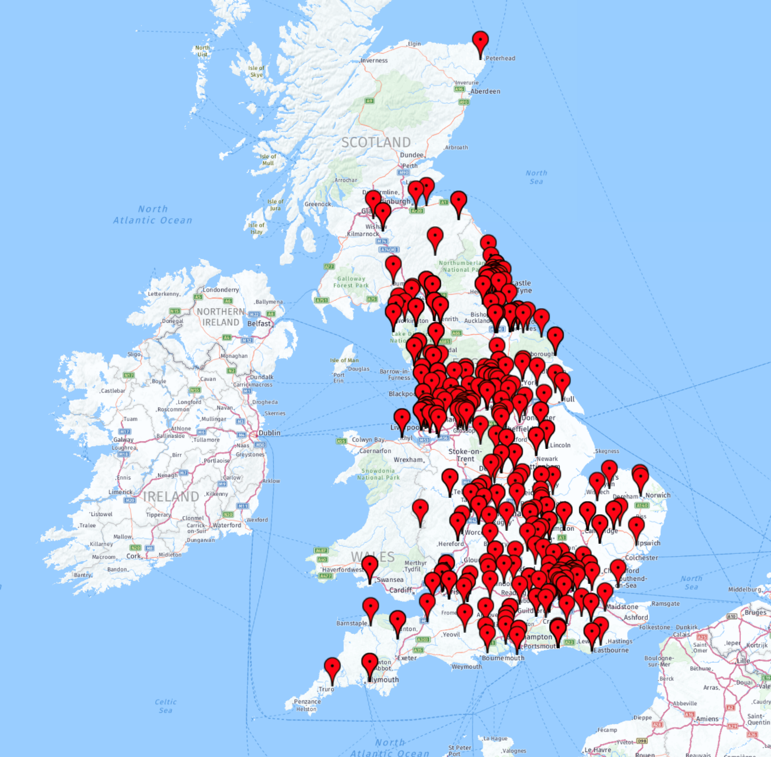
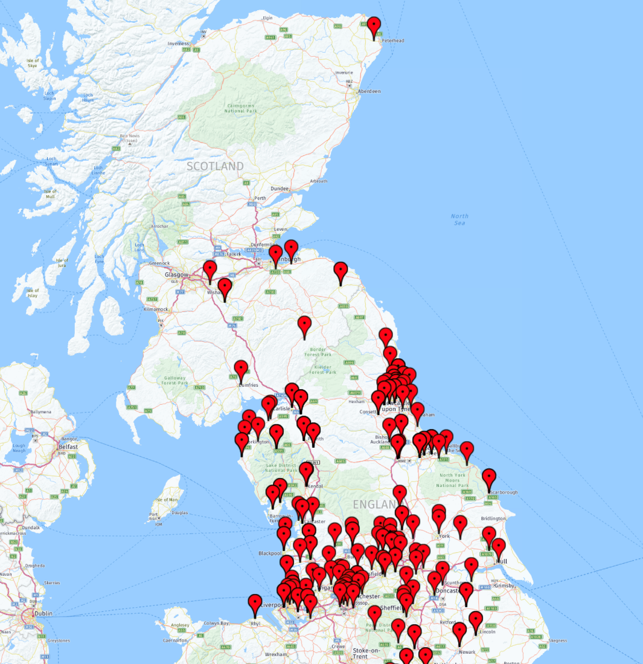
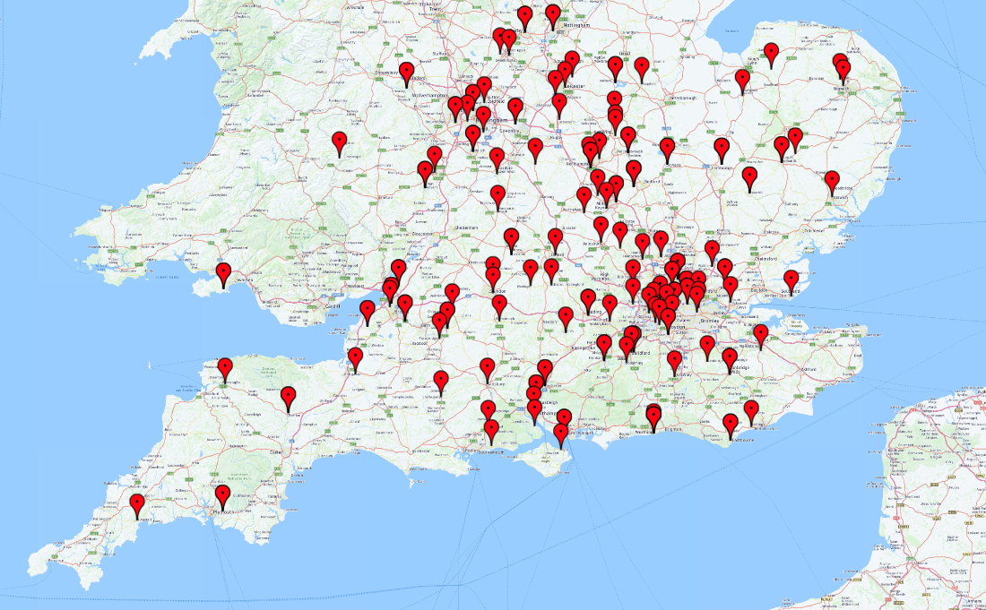
Postcode checker completed using https://www.doogal.co.uk/BatchGeocoding.php software which was a free version. Each pin represents one response from the survey.
Data within the excel document was cleaned manually to give only the first half of the postcode. These were entered into the postcode mapping software of which 19 postcodes were omitted from the software.
From looking at the map it is clear that a large proportion of visitors come from Northern England in particular Manchester and Liverpool areas. The North East also is a hotspot for visitors. The spread across the south of England is more evenly distributed with London being a hotspot. Reasons for this would require further research.
Visitors from Wales and Scotland could be limited are limited because they have their own mountains. A second prediction is that people for south west England have further to travel and the mountains of South Wales and the hills of the Peak District and Dartmoor which are closer as well the south west having an extensive coastal path. Further research in this area would be required.

4. How have you travelled here today?
9 People highlighted that they car shared and 1 person mentioned electric car.

9 People highlighted that they car shared and 1 person mentioned electric car.

5. What made you decide to come to this location?

6. How was your experience today?

Mean rating = 4.97

7. What activities are you hoping to enjoy today?

Submission Dates?
25 July 2021 to 10 Oct 2021
386 useable responses
Sandwood
1. Element Type

25 nil responses for this question and were not used.

2. Are you visiting the area of do you live locally?

3 nil responses not counted on the graph. The 0% for visiting friends/relatives value was 1 leading the graph to count this as 0%.
3. Postcode of where you have travelled from?
Postcode mapping unable to be achieved due to having a place name rather than part postcode.

4. How have you travelled here today?

5. What made you decide to come to this location?

6. How was your experience today?

Rating score of 1 and 2 omitted due to no responses. Mean rating 4.8

7. What activities are you hoping to enjoy today?

Submission Dates? 10 June 2021 to 30 September 2021. 207 useable responses

Thematic Analysis of open text questions 9 and 10
THEMATIC ANALYSIS OF Q 9 – ‘Can you describe in one word, or short phrase, what you value about places like this?’
A Thematic Analysis was applied to the responses for question 9 (methodology is described below) that classified each response within one of the nine ‘themes’ shown in the table. This was done separately to the analysis of questions1-8. The Trust might already be aware of the points below and taking steps to address them. If that is the case it simply validates what the Trust is already doing.
Theme | Number of Responses within the Theme | With ‘Combinations’ Reallocated*
Awesome views | 274 | 298
Peace and quiet / mental health | 139 | 154
Wilderness / freedom | 133 | 139
Nature / outdoors | 110 | 118
Outdoor pursuits | 26 | 32
Combination or 2 or more | 63 | -
Facilities | 16 | 17
Others | 86 | 86
Left blank | 31 | 31
* 2 responses are accounted for by rounding to whole numbers
Visitors’ Interpretation of the Landscape. It is noteworthy that the most common response, by a significant margin, related to the scenery and views. Many of these responses indicated a Romantic interpretation of the landscape, and suggested that visitors very much like the landscape as it currently is (careful of assumptions here – they might like it even more with changes). Many of the responses within the Nature / Outdoors theme also alluded to the ‘natural and unspoilt’ character of these places; whilst these descriptors could be challenged what is important here is that this is how visitors see the landscape. Since the John Muir Trust (JMT) is altering the landscape at some sites (expansion of native woodland at Nevis, Schiehallion and Glen Ridding) then it might be worthwhile finding out more about visitors’ opinions of these alterations, or encouraging positive opinions for a woodier upland aesthetic.
The Dilemma of Too Many Visitors. The responses for ‘Peace and Quiet / Mental Health’ and ‘Wilderness / Freedom’ are similar themes (and could be combined into one), and together make up a significant number of replies. ‘Mental Health’ in particular could be considered a very valuable service in modern times. As visitor numbers grow it will be increasingly challenging for the JMT to maintain these characteristics, particularly to sites that are more accessible for many people (e.g. Glen Ridding). The more successful the JMT is in attracting people to connect to these places, the more it risks losing the very thing that they came to find. (Of course peace and quiet, wilderness, and freedom to roam are all relative and subjective terms – a hillwalker from northern Scotland or someone from a large city might disagree on whether Glen Ridding is indeed ‘peaceful and quiet’). How the JMT manages this dilemma is worthy of consideration.
Combinations of Themes. 63 responses combined two or more of the themes (e.g. “Views peace and quiet” at Glen Ridding, serial 244). This indicates that the themes used here are not mutually exclusive and indeed, for many people they reinforce each other (e.g. perhaps one attraction of the view is the absence of many people). The question asked for ‘one word or phrase’ but perhaps it is the package that attracts people to these JMT sites.
No Responses about the Rare Flora and Fauna. The JMT webpages for each of these sites emphasise its measures to encourage particular plants, birds and lichen. It is noteworthy that none of the 800 responses mentioned or even alluded to this. A theme emerged within the answers about Nature / Outdoors but none mentioned the Trust’s conservation measures or the species themselves. The JMT clearly values particular species at its sites, so might consider how better to inform / inspire visitors about its work.
Self-Selection of Respondents. These responses show what is valued by those people who had chosen to visit a JMT site (even if they weren’t aware it’s Trust-owned), so probably already had something of an appreciation of what these landscapes offer. There are a great many more people who did not visit a JMT site that day, never have and don’t intend to, and for whom it has just not occurred to them. The Trust might consider why this is, what do those people value, would they appreciate the JMT sites if they did visit, does the Trust want to attract them or does it bring other problems (e.g. volume of numbers, preparedness for weather conditions etc.), and how would the Trust engage and manage them?
Summary. If the JMT seeks to ‘connect people and wild places’ then the responses to question 9 suggest that it is succeeding in this area, at least for those people who self-selected to visit on that day. However, there is work for the Trust to do while it encourages woodlands to alter the landscape, in visitors’ appreciation of its rare plants, birds and lichen, and in the engagement and management of new visitors.
The Integrated Thematic Analysis
This followed Braun and Clarke’s 6 step process at https://www.scribbr.com/methodology/thematic-analysis/. This process is designed to analyse responses that are in the format of paragraphs of prose but since question 9 asked for a single word or phrase, several of the steps were unnecessary.
- Familiarisation – The first stage is to read through the data to gain an understanding of it.

- Coding – This stage creates shorthand labels or ‘codes’ to describe the content within the data. The codes shown in the table and diagram (i.e. awesome views, facilities etc.) were developed by identifying similar phrases that seemed to make the same point. The phrases themselves were set by the analyst. Every response was assigned the code that matched it, or the code ‘others’ if none did, or the code ‘combinations’ if two or more of the codes were applicable. Of course there is a degree of interpretation by the analyst within this. Subsequently the ‘combination’ replies were proportionately reallocated amongst the other themes (e.g. a response of ‘lovely views and space to think’ would be reallocated half a point to ‘awesome views’ and half a point to ‘peace and quiet / mental health’).

- Generating themes. This stage was essentially combined with Stage 2 on this project because the data set was a word/phrase rather than a paragraph of prose.

- Reviewing themes. Throughout the allocation of codes to each response the analyst altered, combined, removed and reviewed the codes that were used, largely due to becoming more familiar with the full data set. For example, initially there was a code for ‘peace and quiet’ as that is a common phrase, and another for ‘mental health’ but these are judged to be close enough to mean the same thing so were combined. There were several occasions where the analyst found it necessary to review a single or couple of the codes allocated (using the filter function in excel) to ensure consistency.

- Defining and naming themes. The themes are considered self-evident so have not been further defined.

- Writing up.
An ‘inductive approach’ was used, where the codes and themes were found within the data, rather than deciding the codes/themes first. A ‘latent’ approach was used, where the analyst reads into the subtext and assumptions within the date, rather than only recognising explicit answers.
Motivations for visiting a JMT property
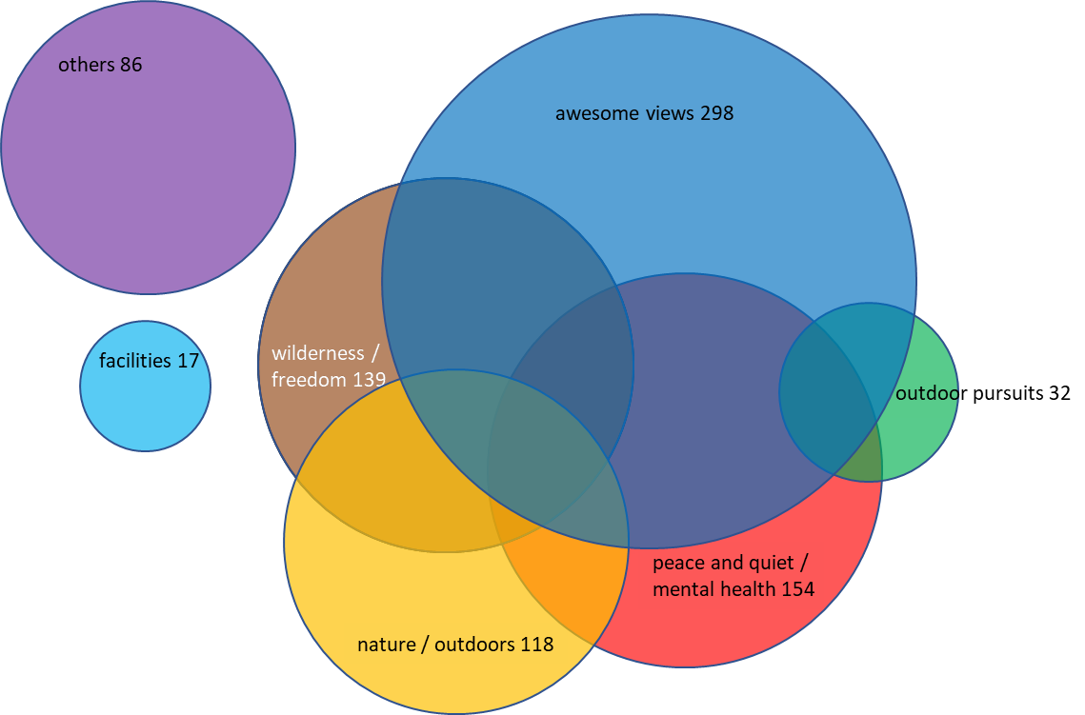

Q10 – ‘Any other comments’
Implications of Minimal Responses and Inconsistent Questioning. Only 110 of the 876 respondents provided an answer to this question. The results looked as though the Ranger at Glen Ridding had completed this section after a discussion with the visitors while the Rangers at the other three sites had left the visitors to complete it themselves. All of this means that Q10 does not really offer a meaningful data set. I attempted to apply a Thematic Analysis as with Q9 but soon realised there weren’t enough responses to draw lessons from (results are below). However, the opportunity for visitors to say whatever came to mind was worthwhile and it suggests topics for future surveys where more specific questions might yield more data, and several of these came from the Ranger’s discussion at Glen Ridding.
Theme | Number of Responses within Theme | Remarks
Blank | 766
Other | 36
Paths | 19
Onward plans | 18 | All from Sandwood and relate to the NC500
Facilities (other than paths) | 14
Navigation aids | 11 | All from Glen Ridding discussion with Ranger
Commented on how busy it was | 9 | Almost all from Glen Ridding discussion with Ranger
Engagement by social media | 3 | All from Glen Ridding discussion with Ranger

Sensemaking
As well as conventional analysis the team undertook using a sensemaking platform to explore useful relationships between categories of survey data. Through identifying clusters and correlations between different user groups, how and why they use JMT sites, as well as their thoughts and feedback the aim is to discover new relationships that will aid the JMT in engaging with their users.
This approach foregrounds particular kinds of ‘warm data’ that can be continuously investigated depending on the questions that are being used to investigate it. The key features of this approach are;
- Complexity based – Rather than separating data out into exclusive categories the data is investigated continuously in multiple contexts so that it can represent connections and clusters. This means that multiple themes can be explored simultaneously.
- Relationships - We can foreground how individuals, communities and populations share themes as well as identifying outliers and unique sub-groups.
- Context - We can move between different contexts (site, age group, activity) and cross-index across categories.
- Population to Individual – It can help us to understand how groups overlap and disperse amongst numerous lines of investigations as well as exploring individual experiences and narratives.
- Practical to Cultural – We can extract specific and distinct examples as well as much broader, more inclusive descriptions.

Data Set Analysis
In entering the data, we first discovered a range of characteristics about the quality of the data itself meaning that Internal reliability (the ability to represent the data coherently) is initially low
- Medium level of absent data (<20%)
- Medium level of problematic data (<20%)
- Very High degree of unique inputs (<75%)
Amongst several categories, there are sections of data missing. For some categories it is possible that the interviewee did not wish to share information, however, in others, it appears that data was collected through observation, rather than interview.
We undertook a process of standardizing inputs and resolving problematic (partially input) data across multiple categories. In reducing the resolution from the unique inputs (e.g. for “What facilities, if any, would have improved your visit? “ responses such as “Car Park needs fixing” and “Need to fix the Car Park”) to standard categories (e.g. “Car Park”), we are then able to increase the ability to relate the data across multiple categories.

Once this process was complete the predicted internal reliability is medium with partial usage. This means that although there is now a higher degree of useable data, there remains a portion of the data that is missing as it was not captured in the field.

Initial Story Telling
Once the data had been reviewed, we were then able to begin representing it on the platform. Initially, we began with colour coding by site and also user group, as well as using single categories to create connections and clusters (see Figure 1).

Figure 1 – Nodes are colour coded by " Visitor type (observation)”, connections are by “How have you travelled here today?”
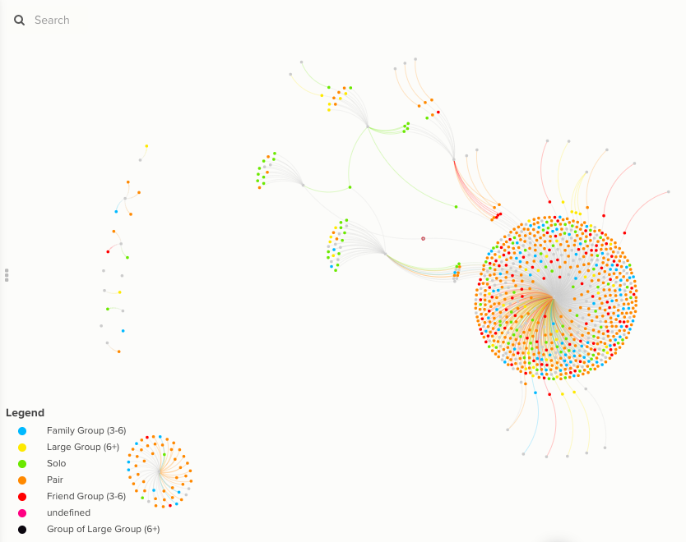
At this basic level we are able to recognise stories such as the dominance of the car and the distinct cluster of campervans and the relatively small number of people that use multiple forms of public transport (e.g. train and bus).
Already there are insights that we are able to see in the data such as those traveling by campervans predominately are in a pair, followed by family groups, with the occasional “solo” visitor.

We were also able to use the partial data on location to geo-locate nodes onto a map (Fig 2), adding colour coding by the site the interviewee visited (Fig 3). We are only able to represent a minority of interviewees at this stage due to the high degree of missing or unusable data limits.

Fig 2 - Location mapped across the UK. Fig 3 - Colour coding by destinations.
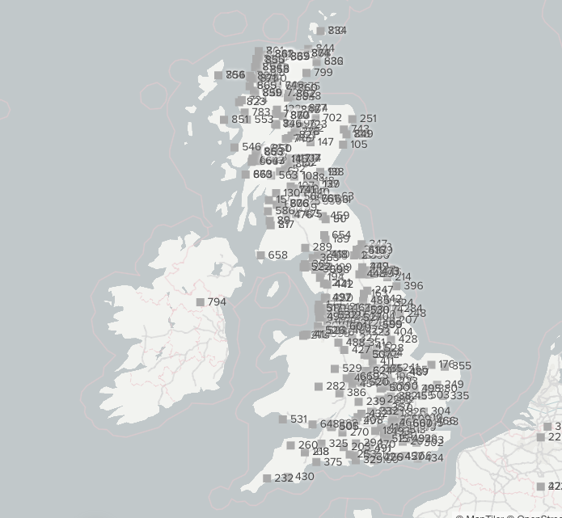
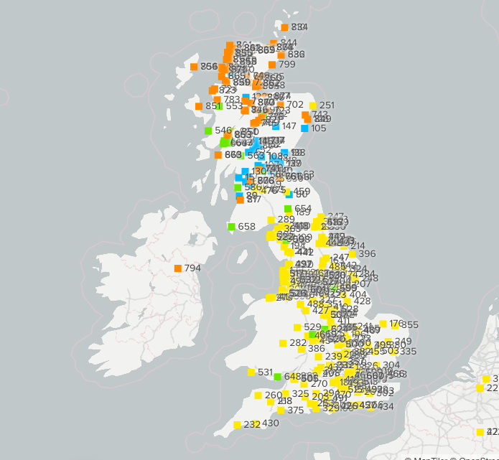
Any observations made from this partial data set must be treated as incomplete and partial, however it begins to potentially illustrate the different degree of clustering for sites and how local or remote visitors tend to be. With developments in how JMT capture information from visitors it would be possible in the future to better recognise the distribution of site visitors, regional bias as well as exploring group/individual narratives around traveling to and accessing the sites.

Discovering Ecologies
With a usable dataset and after some initial storytelling we are then able to move onto exploring deeper relationships. The aim of this stage is to;
- Identify thematic/location/demographic communities.
- Understand how they interrelate and to what degree.
- Use those stories to understand visitor experiences and how they identify with the sites.
Due to the nature of how much can be investigated with the data presented in this format our recommendation would be to arrange sessions to investigate the data to discover useful insights that can be applied to specific areas of JMT`s work.
Below are some initial specific requests from the JMT team and our findings (including images of cluster maps to identify how sites relate to various themes) .

Activities and Thematic Analysis
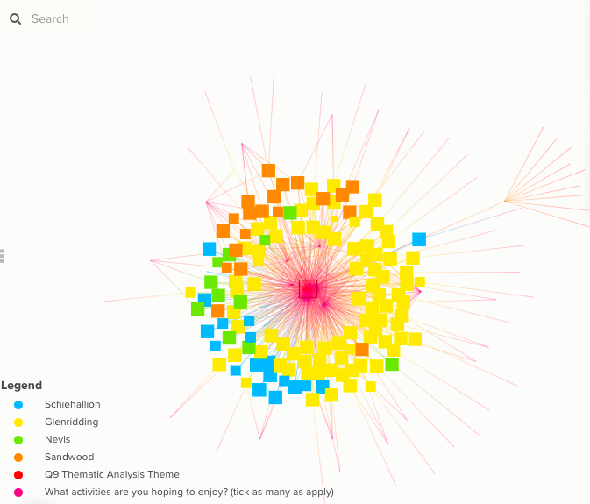
Peace and Quite - Mental Health - High association with Walking and the Scenery, followed by Summit Bagging. Two other meaningful clusters are those that associate photography or swimming with gaining peace and quiet / mental health.

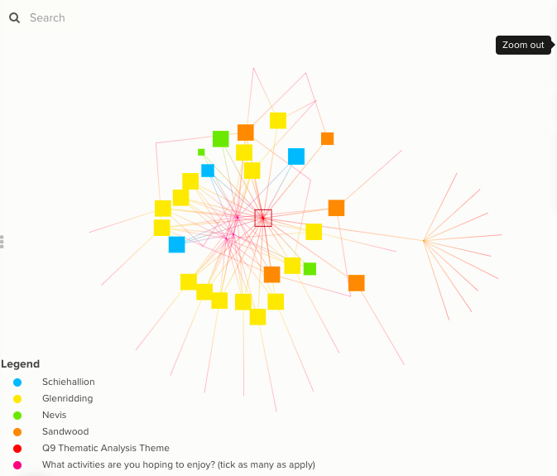
Outdoor Pursuits – Equal association between Walking, Scenery and Summit Bagging.
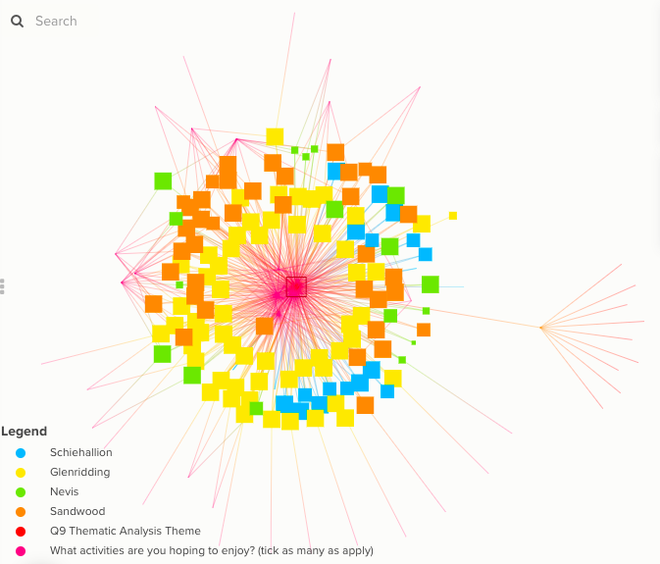
Wildness/Freedom - Higher associations with Walking and Scenery, followed by Summit Bagging. Two medium associations include Bird Watching, Wildlife and Photography.
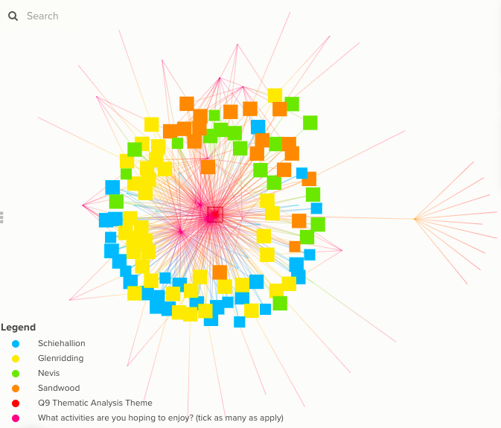
Nature/Outdoors - High associations with Walking and Scenery, followed by Wildlife and then Photography.
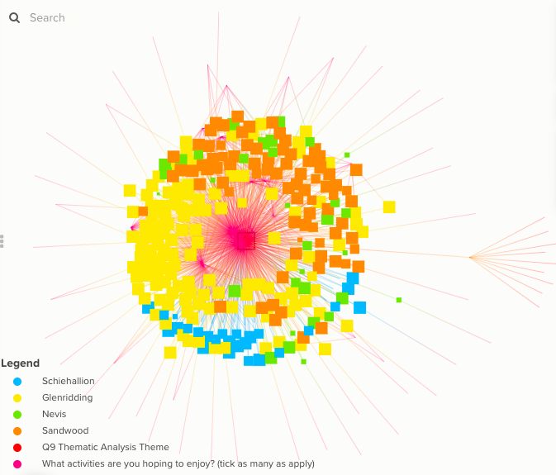
Awesome Views – Most closely associated with Walking and Scenery. Summit Bagging and Ridges follow (predominately from Glenridding), with Wildlife, Photography, Picnic and Cycling also having sizable clusters.
Facility improvement and associations with Activity and Travel

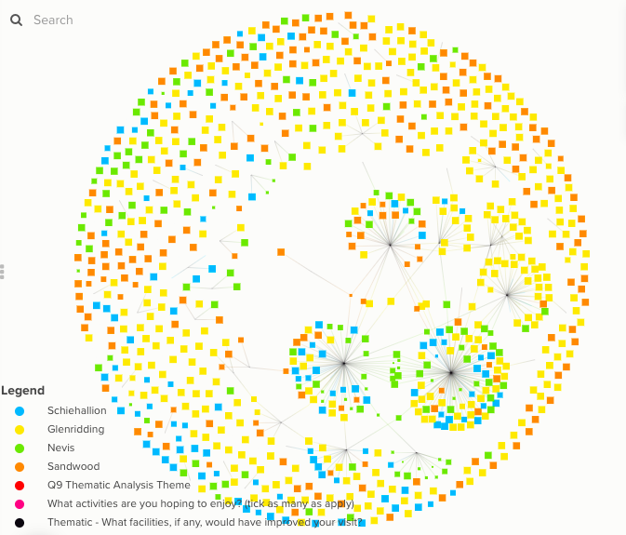
The most common piece of feedback across al sights was improvements to the toilet facilities and car park. Glenridding had strong themes of visitors wanting better signage, better phone signal, the ability to obtain a map, access to water and a Multi-Day pass. Nevis dominated for those that responded saying that wanted better access.
There are no significant associations between those requesting particular improvements and why people came to the site (Fig 4) or how they traveled to the site (Fig 5). The only discrete request came from those traveling to the site by Campervan questing recharging facilities.

Fig 4 Fig 5
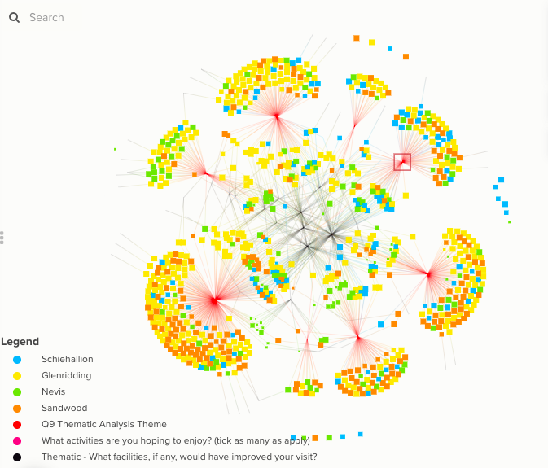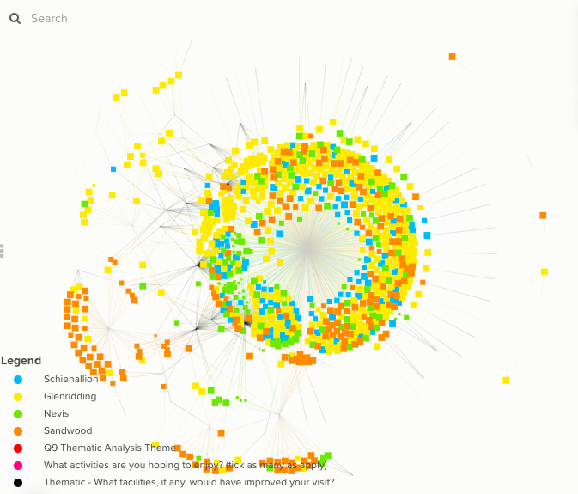

Visitor Promotion
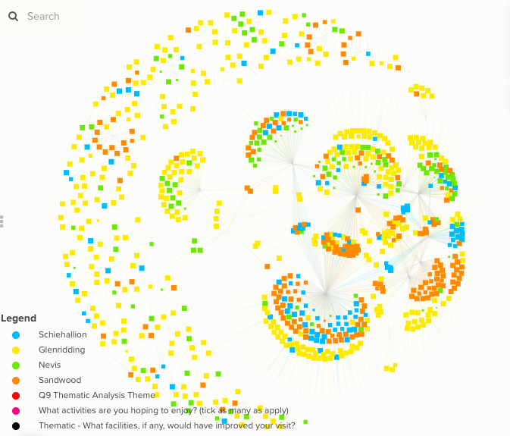
Facebook and Instagram appear to commonly inspire visitors to Sandwood and Glenridding. Nevis` most common feedback was that it was a recommendation, an online press article or visitor information site that prompted them to visit. For Schiehallion it is most often a locally known site or appears on a tick list of places to visit. For Nevis and Glenridding there was also a cluster of visitors who had been before. There were very few visitors (5) that came because of information gained at a visitor centre.

Nevis : Visitor Facilities
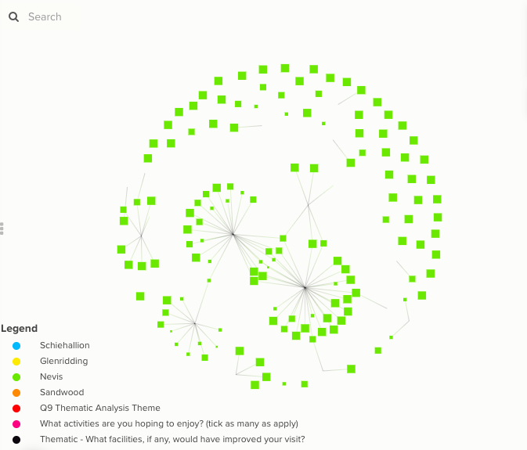
Overall, the feedback highlighted Toilet Facilities, Car Parking and Access as to why the overall experience scored lower. There were also requests for a Café, Seating and Signage.
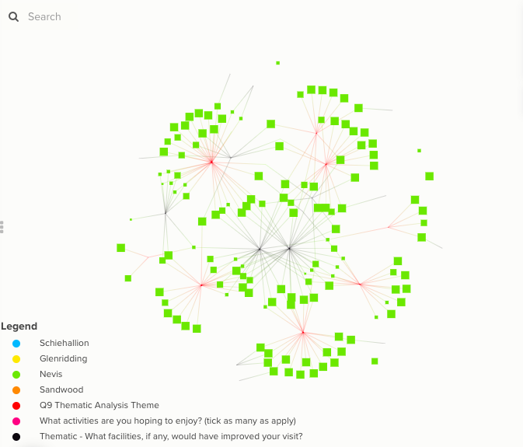
When factoring in the Thematic Analysis of why visitors came to the site, the majority of those citing Access as an issue were attending for Awesome Views. Feedback regarding the Toilet facilities was fairly even across all user groups apart from those seeking Wildness/Freedom, who did not comment at all. In all other cases there were no significant associations between use and views on facilities.

Finding Narratives
As well as understanding how different ecologies of visitors relate to one another, we can then tie this into group and/or singular narratives, giving us a population to personal level of investigation. Below are examples of the of narratives from the survey we are able to piece together.
- There is a partially distinct group who use wild swimming for their mental health at Glenridding, some of which enjoy summit bagging. At Sandwood Swimming is associated more with Cycling and the sense of Wilderness and Freedom.
- A proportion of those using John Muir sites are attracted to the wilderness of the sites however are not particularly well acquainted with being self sufficient in such places.
- There is a friction point within visitors who are attracted to the wildness of the sites but to an extent also wish for modern conveniences (Cafe, Vehicle Recharging).
- Out of 12 visitors that reported Access issues, 11 of them were visiting Nevis and averaged 3.4 in their overall score.
- Those that requested better Signal were all visiting Glenridding and the largest subgroup valued the peace and quiet/mental health aspect of their visit.
- Nevis is the only site to have been given lower scores due to visitors wanting better toilets and car parks. Other visitors on other sites only cited one or the other.
- Schiehallion is the most visited as a meeting place by friends who live nearby.
- Two visitors to Glenridding shared a car journey however one came for the views, the other for the sense of freedom.
- A male in his 20`s drove from Brighton to Glenridding with no map to walk to the summit and the ridges.
- ….etc etc etc etc
Again, the extensive number of narratives that can be investigated would lend itself to working closely with the JMT team to understand in what ways this can help inform their work from the perspectives of promotion, service delivery, community engagement and place-based research.
Some immediate applications might include;
- Capture narratives for typical and a-typical user groups for promotion.
- Create ‘narrative maps for different user groups’ for what JMT would like people to experience to aid with community engagement.
- Create narrative landscapes and explore how JMT`s service delivery affects different user groups.
- Capture narratives to illustrate how JMT site visitors perceive and connect with nature.

Recommendations
Whilst there are useful insights that we were able to gain from the data, the following recommendations are made so that JMT is able to develop a more robust, applicable and responsive approach to visitor engagement.

- Survey structuring - Use clear categories and inputs that allow cross indexing at a population scale as well as collecting personal narratives through multisensory representations.
- Survey questions – Consider narrative-based questions that help capture the affective relationships visitors have with JMT sites. This would create the opportunity to recognise not only how visitors logistically attend the sites, but the values, motivations and community links that exist and support potentially longer-term engagement with JMT and their sites.
- Push to pull – It would be beneficial for JMT to consider how they might move from a pull to push model of visitor data. Through this form of community engagement, we are able to distinguish between members, visitors and user groups to identify future funding opportunities and place-based research.
- Ongoing data collection - Through adopting a push model it will enable JMT to reflect on fresh, relevant data. We would be able to investigate the last 500 captures from one specific site, or cross-index 1000 captures from across all sites to recognise leverage points to inform how the JMT engages with its communities.
- Longitudinal Analysis – Through adopting a long-term, coherent approach to data gathering, the opportunity to map change, both from broad trends as well as in response to specific JMT work and engagement.
- Collect rich stories - Gain an insight into the personal/emotional significance of the spaces through multisensory submissions such as poetry, art, photography. This would enable JMT to not only identify the sense of place that visitors have with sites, but also how particular areas of sites register with different members of the community.
- Filter and focus - With visitor information continuously being gathered, either through members pushing data towards JMT and regular surveys for example, we will then be able to run regular investigations of the date to discover new relationships and contexts that can continuously inform projects and communications.

This approach to investigating visitor data has the potential to inform JMT in how it is addressing its Standards, as well as identifying how it might engage with users and communities differently in the future.
