Vital signs and clinical parameters of febrile children attending out-of-hours General Practice

Authors
S.J. Fisher*, L Jonker⁺

*Cumbria Health On Call, Hilltop Heights, London Rd, Carlisle, CA1 2NS, United Kingdom.

⁺North Cumbria University Hospitals NHS Trust, Cumberland Infirmary, Carlisle, CA2 7HY, United Kingdom.

Corresponding Author
Stacey J. Fisher
General Practitioner, Cumbria Health On Call, Hilltop Heights, Carlisle, CA1 2NS, United Kingdom
e-mail: drstaceyfisher@yahoo.co.uk

Lead Consultant
Dr Craig Melrose, Medical Director, Cumbria Health On Call, Hilltop Heights, Carlisle, CA1 2NS, United Kingdom.

The Online Journal of Clinical Audits. Year; Vol x(x).

Published x

To subscribe to The Online Journal of Clinical Audits go to:
http://www.clinicalaudits.com/index.php/ojca/user/register

Article submission and authors instructions:
http://www.clinicalaudits.com/index.php/ojca/about/submissions

Aims – To audit the recording of febrile paediatric patient examination in out-of-hours General Practice by both nursing staff and general practitioners.
Methods – The standards taken from NICE clinical guideline CG47, feverish illness in children – assessment and initial management in children younger than 5 years, were measured. A data collection sheet was devised and used for the 100 randomly selected patients that attended in the first week of April 2012 with at least fever symptoms.
Results – A total of 96/100 patients (96%) had their temperature measured. Heart rate, respiratory rate, and capillary refill time were measured less often – in 73%, 48% and 44% of cases respectively. However, only 18% of patients had all four vital signs recorded during consultation. Recording of ‘traffic light’ parameters and symptoms took place irregularly, with e.g. hydration status recorded in 38% of cases. However, 86% of parents were given verbal advice in terms of potential follow-up should the patient not improve or deteriorate.
Conclusions – Compliance to NICE guidelines is very high in terms of the key parameter, temperature, but other vital signs and also clinical signs are recorded less often. Although results of this audit compare favourably with other published audit data on this exact topic, increased staff awareness through training is indicated.

Vital signs and clinical parameters of febrile children attending out-of-hours General Practice
Introduction

One of the most common symptoms that children present with in out-of-hours General Practice (OOH GP) is fever, with or without additional symptoms such as diarrhoea, vomiting, earache, and general malaise. NICE published guidance on management of febrile paediatric patients in 2007 [1]. One of the key recommendations was for healthcare professionals to record vital signs, including temperature, respiratory rate, heart rate and capillary refill time (CRT). In addition, a traffic light system was published to assist healthcare professionals taking appropriate action when a child presents with more serious symptoms.

The importance of vital sign measurement and recording is echoed by professional bodies, such as the Royal College of Nursing who have published their own literature on the subject [2]. Apart from being vital in medical decision making, recording of vital signs and associated parameters such as activity of the child, respiratory status and hydration levels is crucial for a practising healthcare professional from a litigation point of view.

Aims

Conduct a retrospective audits to determine if paediatric patients under the age of 5 with fever symptoms are examined in line with the NICE guidelines, as evidenced by recordings in electronic medical notes.

Audit Standards

Parts of following guidelines were used for measuring compliance:
NICE Clinical Guideline 47: feverish illness in children – assessment and initial management in children younger than 5 years [1].

Methods

Cumbria Health On Call Ltd (or CHOC) provides OOH GP services for the whole of Cumbria. Service provision runs from 6.30pm to 8am on weekdays, plus bank holidays, and a full 48 hours for each Saturday and Sunday. The first week of April 2012, covering Sunday 1st to Sunday 8th was randomly chosen as the audit period; this also coincided with an additional OOH day since Friday 6th April was Good Friday. A data collection sheet was designed in Excel based on the clinical audit tools on the NICE website. The data was collected from patient contact sheets that CHOC Ltd uses. In line with the guideline, only patients who were under the age of 5 and presented with at least the symptom ‘fever’ were included in this audit. Those patients who were consulted only over the telephone were excluded because the vital signs and other observations will be self-recorded by patients’ parents or guardians. It is unlikely that certain vital signs such as heart rate, respiratory rate and CRT will have been recorded by parents, or requested by healthcare professionals. Therefore the standard contained in CG47 regarding remote assessment of patients was not considered. This audit was not designed to draw inferences regarding any relationship between vital sign recording and clinical assessment or the type of healthcare professional that saw the patient, nor any diagnoses made or further patient outcomes.

Results

Patients, or their parents & guardians, usually contact OOH GP services via telephone in the first instance. The patient is then triaged and classed as either: routine, urgent or needing immediate attention. Patients can either visit a clinic at one of various locations around Cumbria, be seen by a doctor at home or have a consultation over the phone. As mentioned in the Methods section, we excluded telephone consultation – only two such consultations took place during this audit period. Table 1 shows that routine calls, with patients seen at one of the clinics, are by far the most common type of consultation for children with fever. Furthermore, although OOH GP services cover primarily late evening to early morning, in our audit most patients presented during the day (see Table 1).

Because of the nature of OOH GP services, patients can be seen by different types of healthcare professionals. In this audit, patients were seen by either a nurse only, a GP only, or both professions in one consultation (see Figure 1). The latter situation can arise when a patient is first triaged over the phone and then invited to come to the clinic. Occasionally, a patient can be seen e.g. by a nurse first and then passed on to another nurse or doctor because of the presenting symptoms or for a second opinion.

Table 1: Demographics of patient population

Number of patients | 100
Mean patient age (in months) | 27
Youngest patient (in months) | 5
Oldest patient (in months) | 59
Routine calls | 94
Urgent calls | 6
Immediate calls | 0
Patient seen at base | 95
Patient seen at home | 5
Mean time of the day call was logged (hr:min) | 13:19
Nr of calls between midnight and 6am | 5

Figure 1, Type of healthcare professional(s) that saw the patient

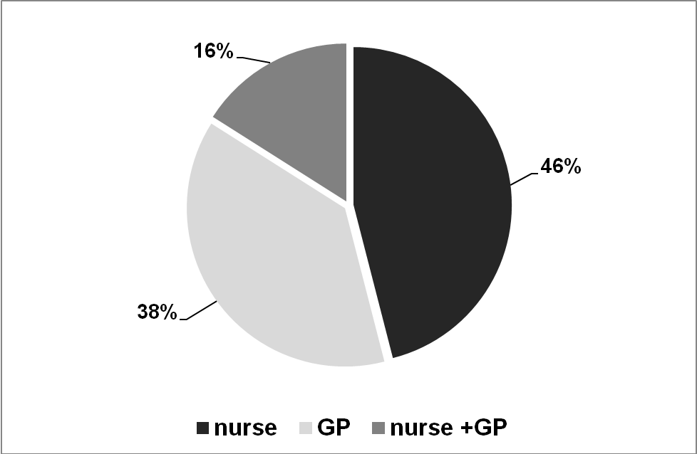

Recording of vitals sign measurement is summarised in Figure 2. NICE states that all four vital signs should be measured as a matter of course in a febrile child; this was achieved in only 18% of cases. Compliance for individual parameters was: temperature 96/100 (96%), heart rate 73/100 (73%), respiratory rate 48/100 (48%) and CRT 44/100 (44%). Oxygen saturation levels were recorded in 24% of patients. On two occasions it was noted that the healthcare professional in question was not able to obtain a measurement. Various clinical signs of the patient, which together form the ‘traffic light’ system, should also be recorded. They include: (skin) colour, activity, respiratory function, hydration levels, and any signs of meningism. Figure 3 summarises recording of clinical signs. The colour of the child’s face was recorded in 23 patients; of those, 6 patients were pallor and none were classed as pale, mottled, ashen or blue.

Figure 2, Recording of patients’ vital sign measurement

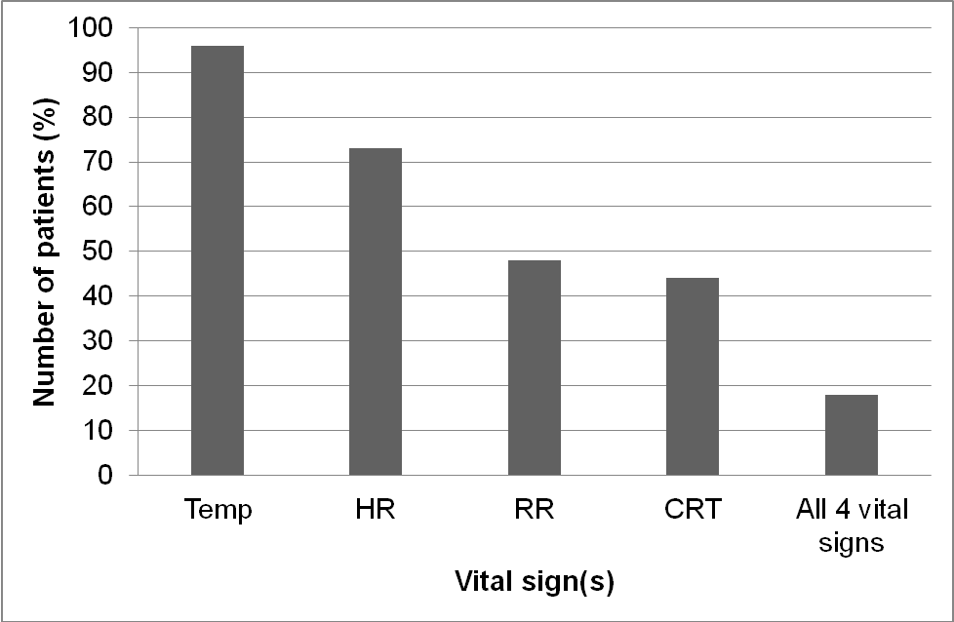

Figure 3, Recording clinical examination of patients

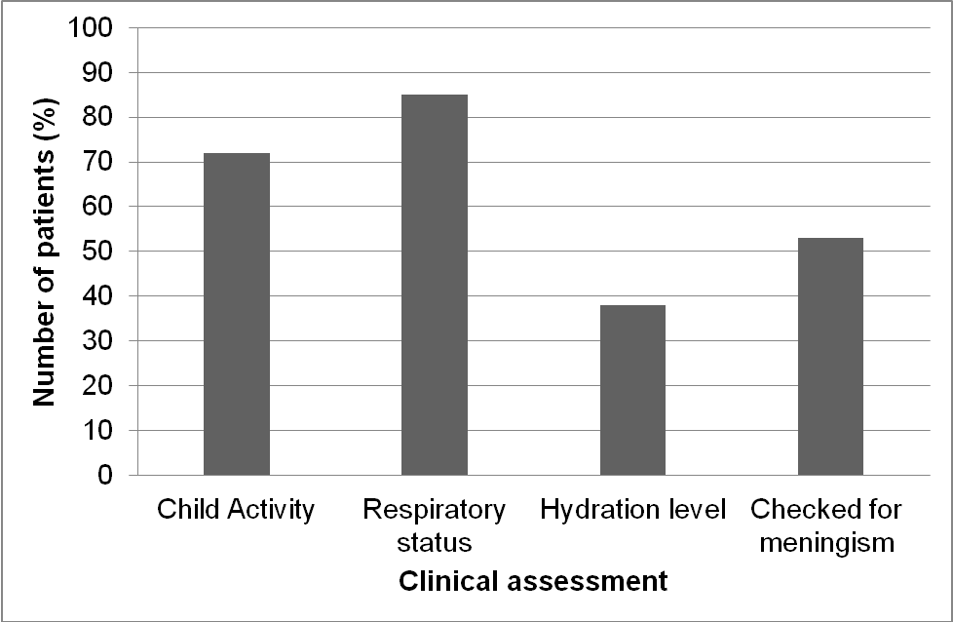

Discussion

A study by Kallestrup and Bro from 2003 [3] showed that parents & guardians of febrile children visited out-of-hours GP clinics because they did not feel they are in control of the condition, even if they felt the condition was not serious. Virtually every parent expected their child to be examined, partly because of fear of serious disease [3, 4]. It is likely that parents’ expectations and anxieties have not changed. Taking vital sign measurements and undertaking & recording clinical examinations should help to instil parents’ confidence in terms of the level of care provided to their child [5].

Our data compares favourably with results from another study conducted in a Paediatrics Department in a Hospital [6]. In that audit, temperature was measured in 65% of cases at baseline and in 71% of cases after the introduction of a card sized aide memoir containing standard figures for temperature, respiratory rate and heart rate in children under 5. The figures for heart rate and respiratory rate after the card introduction of the vital sign card were 75% and 60% respectively. Therefore, our figures presented in here are on a par with those from the re-audit in the Bird et al paper [6]. CHOC, the company that delivers out-of-hours in our region, already provides staff with an information sheet and training on vital signs in children, written and delivered by a paediatric consultant. This may have contributed to the encouraging figures for temperature measurement at least.

There is evidence that occasionally some clinicians see little value in performing a vital sign measurement. For example, 70% of GPs interviewed in a study by Thomson et al stated that the respiratory rate would be useful (score 4 or 5 out of 5 on usefulness Likert scale) to measure in a generally unwell child; for a generally well child this decreased to only 28% [7]. Similar figures were obtained for heart rate, whereas more GPs valued temperature measurements as useful. This rationale may have contributed to lower compliance for respiratory and heart rate measurements in our audit, particularly since the majority of patients were perhaps not very unwell (on the basis of appointment urgency). Recording levels were also lower for clinical parameters such as including respiratory rate and CRT. There may be contributing factors to a lack of conducting and/or recording these examinations. If a differential diagnosis is made early in the consultation, there is a risk that the healthcare professional focuses investigations into that direction. One example scenario may be a child presenting with earache or a sore throat, both common causes of fever.

Although recording of vital signs is encouraged in national guidelines, there is the question whether a recorded figure is clinically valid. One prime example is CRT. It has been shown that the ambient temperature of the consultation room (or patient’s house if it concerns a home visit) significantly influences the CRT value. In a cohort of patients, measured twice at different ambient temperatures, this varied from on average 0.85 sec at 25.7°C to 2.39 sec at 19.4°C [8].

Conclusions & Recommendations

Educational activities, aided by sharing collated audit data, should help to highlight where best practice is not applied. Opportunities for this are induction days, training days, staff meetings.

Clinical staff should be reminded that vital signs and clinical parameters should always be recorded, even if the result is negative or normal.

References

- NICE Clinical Guideline 47: feverish illness in children – assessment and initial management in children younger than 5 years, http://www.nice.org.uk/CG047 (last accessed online 5 July 2012)
- Royal College of Nursing Standards. Standards for assessing, measuring and monitoring vital signs in infants, children and young people. Dec 2007, revised Aug 2011.
- Kallestrup P and Bro F. Parents’ beliefs and expectations when presenting with a febrile child at an out-of-hours general practice clinic. BJGP 2003; 53:43-44.
- Kai J. What worries parents when their preschool children are acutely ill, and why: a qualitative study. BMJ 1996:313;983-6.
- Houston AM, Pickering AJ. ‘Do I don’t call the doctor’: a qualitative study of parenteral perceptions of calling the GP out-of-hours. Health Expectations. 2000: 3;234-242.
- Bird C, Shea A, Michie CA, George G. A simple intervention improves the recording of vital signs in children presenting to the emergency department. Emerg Med J. 2009; 26:698-700.
- Thompson M, Mayon-White R, Harnden A, et al. Using vital signs to assess children with acute infections: a survey of current practice. BJGP 2008; 58: 236–241
- Gorelick MH, Shaw KN, Baker MD. Effect of ambient temperature on capillary refill in healthy children. Pediatrics. 1993; 92:699-702.

